18011644

WEDE5010 TASK3

**User’s emails saved in Google Sheets**

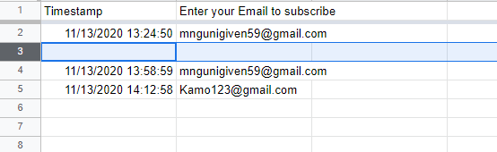

**Email notification in my mailbox**

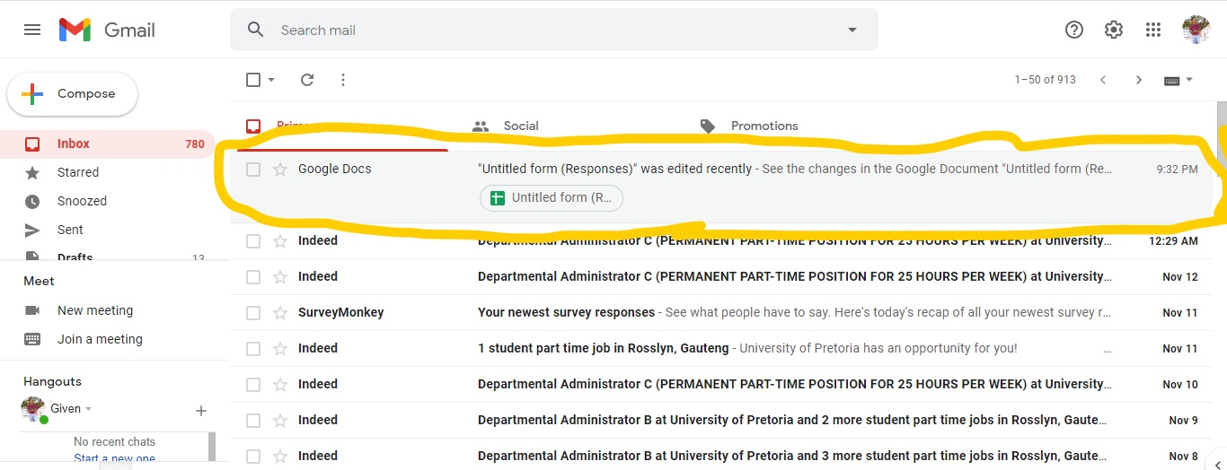

**Opened mailbox**

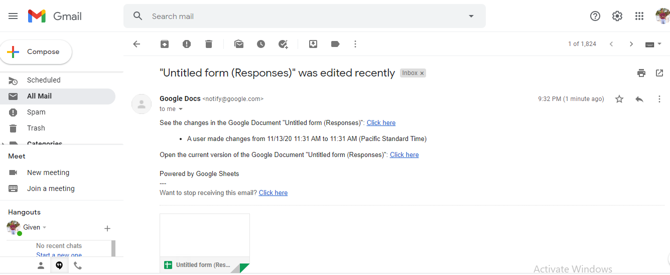

1. **What were the most and least beneficial aspects of this course?**

* The most beneficial aspects of this course was to learn how to develop a website from the scratch.

1. **How did each of the learning units contribute to your knowledge of web development?**

* Learning units have contributed so much because we were learning how to develop/create a website step by step , one learning units building on one another.

1. **How did the knowledge gained from each of the learning units assist you in completing the tasks in this POE?**

* The knowledge I’ve gained throughout this learning units have made me more curious about websites, everything I have covered in previous learning unites were good for me to complete this POE.

1. **Do you think you will use the skills in this course in your career? If yes, explain how.**

* Yes , because being a developer requires me to have a knowledge about website’s too because I cannot be only working on developing stand-alone or Android applications only. I need to know both web and app development.

1. **If you were to rewind life one semester, what would you do differently in this course and what would you do the same?**

* I would listen to the lecture but not to rely on them only, I would do more research by myself, dig much information about web developments.